FireSafe Flathead Meeting Notes – Thursday, November 29, 2018. 9-11am
In attendance: Rick Trembath, Deb Starling, Mike Frost, Bill Swope. Mike West,
Mike from SVC, Lincoln Chute, Allen Chrisman, Randy Sundberg, Rich Baginski, Ali Ulwelling,
Rick Sacca, Jan Cronin, Jeremy Pris, Jeremy Harker, Dick Haberkern.
Next Meeting: 9am Thursday, JANUARY 24, 9-11am in the DNRC Conference Room.
Please send updates, events, articles, agenda items!
Please read the attached CMAT report and Guiding Principles.
We will use this to guide discussion & goals for 2019 at our next meeting.

A loose meeting, no times on agenda items. Started with thoughts on the Camp Fire in Paradise, CA.
(If you have not seen this yet, here are some drone images from the Camp Fire: Butte County webmap of the Camp Fire)
[When I called Peter Kolb about pile burning (more about that later) he mentioned that he will be talking about the Camp Fire with KGVO radio Friday morning at 8:30am. Listen in here: http://newstalkkgvo.com/category/talk-back/
Bill Swope said that there has been an increase in interest. Concentrate on the Home Ignition Zone and defensible space specifications, caulking cracks is not enough & unique situations will still result in home destruction. HOAs are getting involved with coordinated efforts. Some areas can plan for Safety Zones for residents.
Rick Trembath agreed in the increase in interest. The fire moved from the P Pine forest to the subdivision, similar could happen here under extreme conditions. Individuals are the first to respond, government is second.
Dick H asking about incentives for private landowners to get fuels work done. Mike West explained the cost-share programs, the tangible and intangibles of this kind of work: people can feel safer, make their community safer, feel like they are a part of something larger, forest health & making a safer more-successful firefighting environment.
Many Lakes has also seen an increase in interest and projects completed (talk more with Randy about this.)
Mike Frost had a point about the importance of planning for evacuations, that also led to discussion about the impossibility of evacuating that many people, that fast. Again, the importance of safety zones or safe spaces within or near communities. New Sherriff may offer new opportunities for his discussion.
Jeremy Pris and Rick Sacca agreed in the increased interest, but it has also resulted in a fear of fires and 911 calls reporting debris burning. Is there potential to update the burn permit system and use it for more information? FOLLOW-UP: Check the legislative website for potential changes - Montana Legislature (change in the dates of legal fire season that would ultimately affect burn permit process as well)
How can WE, our group, help with education of public? County may add follow-up questions to dispatcher training. Get the local news media involved and invite out to a pile burn and talk about what is safe and what is NOT safe, that each phone call results in the responders.
Check out Pile Burning Lessons Learned: https://fireadaptednetwork.org/pile-burning-lessons-learned/
[** UPDATE** So, I went to the field to meet with Tai Foley where he was burning many piles on a property out in Shelter Valley on Friday. The landowners had attended a “Pile burning workshop” in Missoula, of all places!! It reminded me that Rick Trembath (Thanks, Rick!) had shared a flyer about a Debris Burning workshop that Peter Kolb and MSU Extension had advertised and I think we should plan for something like that here. See attachment. I called Peter Kolb and we can plan for him to host a workshop here next fall, we just need to provide the location. More at our next meeting!]
So, what else can we do to boost our efforts in 2019?
Mike West – Order the Smokey Signs we talked about for the fire stations AND include the “Open Burn Season” messaging. Ali has an estimate for cost ($3,200+/ea) and will check with our Montana Corrections sign shop for competitive pricing or get them ordered from the company in Colorado.
Signs we are looking at are like the ones the Flathead NF has in Hungry Horse:
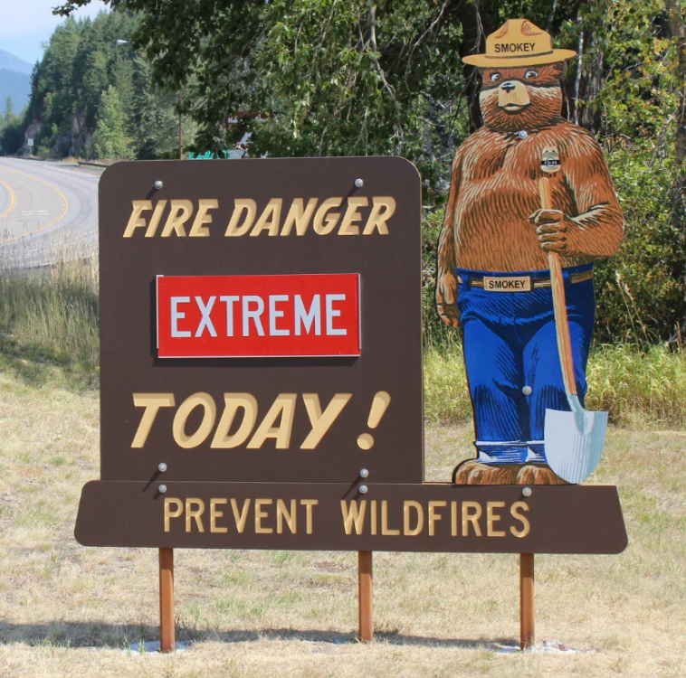
Deb Starling – The FEMA pre-mitigation grants have been extended from November 30 to March 1. There is a FEMA grant writing training in Helena January 15 and 17. Lincoln suggested talking with Ed Burlingame, too, if people need assistance with the FEMA grants writing. Also, all grants are committed to projects on the ground. In running for Western States WUI grant but would not see until 2020. Talking about expanding the Bootjack opportunity.
Randy Sundberg – Home assessments. Is there an opportunity for a train-the-trainer to get more people qualified?
Ali – There is a Home Assessment Training offered in Missoula this spring (see attachment). SIGN UP. If there is enough interest, they will consider hosting another course in Kalispell.
Rick T – Can also share the Jack Cohen home assessment video for folks. Question: what kind of fire are we assessing for..?
Lincoln – We had also talked about putting together short clips locally to share with people. Also, CWPP meeting date will be shared. Plan for the community meeting & Byron Bonney in February.
Ali – Presentations are planned for the spring:
Lakeside/Somers – Era of Megafires & Community Conversation, Lakeside school, mid-May.
West Glacier – Community Wildfire Conversation at the Montana House, early-June
North Fork Firewise Day – Era of Megafires and others
We will also attend the next Chief’s meeting to let them know more about our group and what we can do to help support these community efforts, if they are interested. UPDATE: Rick Sacca and Ali will be going to the meeting, Monday Dec 10.
Mike West – Revised Forest Plan is coming out in December and will reflect increase in pace & scale, increased targets and funding for fuels reduction.
Fuels Mapping Project – Ali, Mike, and Rick Connell are meeting and looking at what exists and what we would like to have here. (Cross Boundary Story Map)
Lincoln commented that the open house for the Crystal Cedar project was well-attended, but there is some push-back from neighbors.
Bill shared that they are talking with the Hungry Horst silviculturist to increase the shaded fuel break in the North Fork.
Allen shared that there was a lot of good work done in the North Fork in conjunction with the fires this past summer. They have put together a list of contacts, equipment, and capabilities for the future. They will be revising their CWPP.
Ali - Don’t forget to look through the CMAT report before our next meeting

11:30 Finish cranberry lemon scones and adjourn

Au 12/5/2018

